NCS4 – Interpol

|  |  |
| --- | --- |
|  | Interpol Logo |

***Major national and international sporting events such as the Olympic Games, FIFA World Cup tournament, NFL Super Bowl, and Boston Marathon present many policing and security challenges for event hosts.  These events take place in large, and complex locations; such events can attract a range of criminal activities from disorder and violence to cyber attacks and terrorism.  Event hosts and venue owners are faced with the challenge of providing a smooth-running and successful event while keeping event participants and spectators safe and secure. Thus, a partnership was formed between NCS4 and INTERPOL to address these safety and security challenges.***

**PROJECT STADIA**

In 2012, INTERPOL, in cooperation with Qatar, established [Project STADIA](https://www.interpol.int/INTERPOL-expertise/Stadia/Project-Stadia) to create a **Center of Excellence** to help INTERPOL member countries in planning and executing policing and security preparations for major sporting events.  With its global network of experts in 192 member countries, INTERPOL is ideally placed to serve as a centralized hub for research, design, planning coordination and training to help meet this challenge, within a structure that assures high standards and quality.

**NCS4 AND INTERPOL**

In 2016, an agreement was established **between INTERPOL and the University Southern Mississippi's USA, National Center for Spectator Sports Safety and Security (NCS4)** built on a common interest of contributing to police cooperation through strengthening training activities for police officers serving sport security functions. INTERPOL helps to build the capacity of police in their 192 member countries, equipping them with the knowledge, skills and best practices needed to meet today's policing challenges. <http://news.usm.edu/article/center-spectator-sports-safety-and-security-signs-agreement-interpol>

**TRAINING OPPORTUNITIES**

NCS4 and INTERPOL are developing six international training courses (see inset for INTERPOL and NCS4 Training Courses). The first course, [Sport Security Executive Management](https://news.usm.edu/article/ncs4-partners-interpol-new-sports-security-course), was taught from September 12-14, 2017, in Lyon, France. Participants from 27 countries attended the inaugural course. It is the first course in the world to receive INTERPOL accreditation. The target audience for all six courses are Police Executives and Incident Management Team members.

**INTERPOL and NCS4 Training Courses**

* **Sport Security Senior Management Training Course (Available as of September 2017)**
* **Risk Management Challenges for International Sporting Events (Available as of April 2018)**
* **Evacuation Challenges for International Sporting Events (Projected for September 2018)**
* **Crowd Management for International Sporting Events (Projected for April 2019)**
* **Incident Management for International Sporting Events (Projected for September 2019)**
* **International Sporting Events: Safety and Security Case Management (Projected for April 2020)**

Beginning in the fall of 2020, Police Executives and Incident Management Team members who complete all six courses may be eligible to earn the **International Sport Safety and Security Professional Certificate**.

**[STRATEGIC PARTNERS](https://www.ncs4.com/train/strategic-partners)**

* Axis Communications
* Babel Street
* CEIA
* Dell EMC, a part of Dell Technologies
* Johnson Controls’ Building Technologies & Solutions
* Microsoft
* OT-Morpho
* NEC Corporation of America

[*Click here*](https://www.ncs4.com/train/strategic-partners) to see more information on our strategic partners.

**CONTACT**

For information on the **International Sport Safety and Security Professional Certificate**

please direct inquiries for response to:

Dr. Lou Marciani, Ed.D.

Director, National Center for Spectator Sports Safety and Security

University of Southern Mississippi

001-601-266-5675

Lou.marciani@usm.edu E: lou.marciani@usm.edu



For information on attending and scheduling **INTERPOL Project STADIA** courses, contact:

Mr. Khaled HATEM

Specialized Officer

Project STADIA – Safe and Secure Major Events

Operational Support & Analysis Directorate

INTERPOL General Secretariat

T +33 4 72 44 5748

M +33 6 29 55 6417

E: [K.HATEM@INTERPOL.INT](mailto::K.HATEM@INTERPOL.INT)

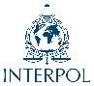

***About NCS4***

*The National Center for Spectator Sports Safety and Security (NCS4) at*[*the University of Southern Mississippi*](https://www.youtube.com/watch?v=kXfZaBj_a0E)*, supports the advancement of sport safety and security through training, professional development, academic programs and research. NCS4 collaborates with professional leagues, open access events, intercollegiate and interscholastic athletics, along with professional associations, private sector firms, and government agencies. It is a critical resource for sport venue managers, event managers, first responders, and other key stakeholders.*

***About INTERPOL***

*INTERPOL is the world’s largest international police organization, with 192*﻿[*member countries*](https://www.interpol.int/Member-countries)*. Their role is to enable police around the world to work together to make the world a safer place. Their high-tech infrastructure of technical and operational support helps meet the growing challenges of fighting crime in the 21st century.*

**International Sport Safety and Security Professional Certificate**

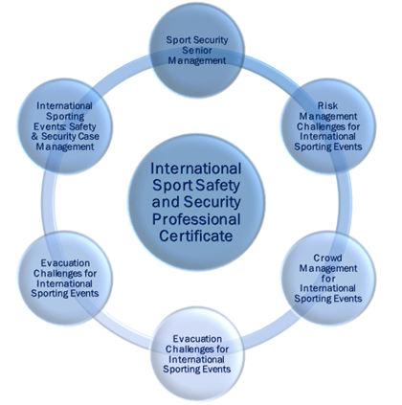The National Center for Spectator Sports Safety and Security, the University of Southern Mississippi, USA, in conjunction with INTERPOL Project STADIA, will offer the **International Sport Safety and Security Professional Certificate** to attest that the trainee has successfully completed the required six courses offered by Project STADIA. Each 3.5-day course is designed to build police capacity and is developed for accreditation by INTERPOL. INTERPOL recommends the courses be completed in order however, consideration will be given on a case-by-case basis to those who complete the courses in a different order.

Police executives and incident management team members who complete all the training courses will develop their risk management, decision making, communication, incident management, crowd management, emergency operations planning, evacuation and protective action, and team management and leadership skills. Trainees who successfully complete each in-residence course are eligible for obtaining the **International Sport Safety and Security Professional Certificate**.

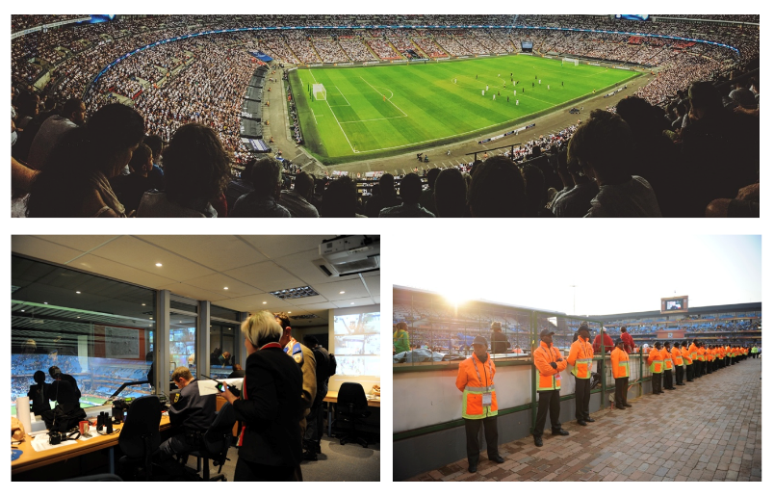Capacity building and training play a key role in INTERPOL’s overall mission to enhance international police cooperation. The purpose of the **International Sport Safety and Security Professional Certificate** initiative is to enhance knowledge and encourage innovation, to turn training into operational practice for international sporting events.

**WHO**: Police Executives and Incident Management Team members.

**WHAT**: International Sport Safety and Security Professional Certificate may be awarded to participants who successfully complete all six training courses.

**WHEN**: First certificates will be awarded beginning in 2020.

**WHERE:** Initial courses are taught at INTERPOL headquarters in Lyon, France. Future courses will be taught by request to INTERPOL Project STADIA.

**Course Schedule for Obtaining the**

**International Sport Safety and Security Professional Certificate**

|  |  |  |
| --- | --- | --- |
| Projected Availability Date | Courses Available to INTERPOL Countries | Training Location |
| April 2018 | First offering of ***Risk Management Challenges for International Sporting Events Training Course*** | Lyon, France |
| Courses Available Summer 2018 | * ***Sport Security Senior Management Training Course*** * ***Risk Management Challenges for International Sporting Events Training Course*** | By Request to INTERPOL Project STADIA |
| September 2018 | First offering of ***Crowd Management for International Sporting Events Training Course*** | Lyon, France |
| April 2019 | First offering of ***Evacuation Challenges for International Sporting Events Training Course*** | Lyon, France |
| Courses Available Summer 2019 | * ***Sport Security Senior Management Training Course*** * ***Risk Management Challenges for International Sporting Events*** * ***Crowd Management for International Sporting Events*** * ***Evacuation Challenges for International Sporting Events*** | By Request to INTERPOL Project STADIA |
| September 2019 | First offering of the ***Incident Management for International Sporting Events Training Course*** | Lyon, France |
| April 2020 | First offering of the ***International Sporting Events: Safety and Security Case Management Training Course*** | Lyon, France |
| Courses Available Summer 2020 | * ***Sport Security Senior Management Training Course*** * ***Risk Management Challenges for International Sporting Events*** * ***Crowd Management for International Sporting Events*** * ***Evacuation Challenges for International Sporting Events*** * ***Incident Management for International Sporting Events*** * ***International Sporting Events: Safety and Security Case Management*** | By Request to INTERPOL Project STADIA |
| Fall 2020 | **International Sport Safety and Security Professional Certificate Program** commences |  |

NCS4 – ICT

|  |  |
| --- | --- |
|  |  |

***The terrorist attacks on the night of 13 November 2015 at the Stade de France and the Bataclan Theater on in France showed that even small terror cells and “lone wolfs” can strike major national and international sporting and entertainment events. Beginning with the attacks on the Athlete’s Village at the 1972 Olympic Games in Munich, Germany through today, terrorists are evolving their methods and tactics to strike large crowds of spectators and gain an audience for their organizations and ideology. Countries that host large spectator sports and entertainment events like the Olympic Games, the FIFA World Cup tournament, the NFL Super Bowl, and Boston Marathon must prioritize risks and allocate scarce resources to protect people attending large spectator events.  Event hosts and venue owners are faced with the challenge of providing a smooth-running and successful event while keeping event participants and spectators safe and secure from terrorism. Thus, a partnership was formed between NCS4 and ICT to address these safety and security challenges.***

**NCS4 AND ICT**

In 2017, the **International Institute for Counter-Terrorism (ICT)** and the **University Southern Mississippi's USA, National Center for Spectator Sports Safety and Security (NCS4)** signed a Memorandum of Understanding to foster international cooperating in education, training, research, and thought leadership in counter-terrorism. Given the respective knowledge of each institution, ICT and NCS4 are developing a series of educational products about terrorism and counter-terrorism that will benefit law enforcement, security and intelligence agencies around the world who are dealing with threats to sports safety and security. The institutions will focus on development of joint training programs and addressing needs of industry and counterterrorism and sports safety and security professions.

**JOINT TRAINING PROGRAMS**

ICT and NCS4 are currently developing a 3.5-day pilot course for senior leaders and managers. The inaugural course is planned for 12-15 July 2018 in Louisville, Kentucky (USA). The course will be taught by subject matter experts in international counterterrorism and sport safety and security from ICT and NCS4. The course is a scenario-based practicum, teaching participants about terrorism, how terrorism is evolving, the challenges of counterterrorism, and how to mitigate the risks posed by terrorism through operations planning and protective measures. This unique course will use a Red Team to foster understanding about how terrorists plan, and will allow participants to use an actual professional or collegiate sports event and venue to evaluate their own plans.

***About NCS4***

*The National Center for Spectator Sports Safety and Security (NCS4) at*[*the University of Southern Mississippi*](https://www.youtube.com/watch?v=kXfZaBj_a0E)*, supports the advancement of sport safety and security through training, professional development, academic programs and research. NCS4 collaborates with professional leagues, open access events, intercollegiate and interscholastic athletics, along with professional associations, private sector firms, and government agencies. It is a critical resource for sport venue managers, event managers, first responders, and other key stakeholders.*

***About ICT***

*Founded in 1996, the* [*International Institute for Counter-Terrorism (ICT)*](https://www.ict.org.il/) *is one of the leading academic institutes for counter-terrorism in the world, facilitating international cooperation in the global struggle against terrorism. ICT is an independent think tank providing expertise in terrorism, counter-terrorism, homeland security, threat vulnerability, risk assessment, intelligence analysis, national security and defense policy. ICT also serves as a joint forum for international policymakers and scholars to share information and expertise through research papers, situation reports and academic publications for worldwide distribution. A number of international seminars, workshops and conferences are organized monthly by ICT to discuss and educate on global and regional issues of security, defense, and public policy in order to better facilitate the exchange of perspectives, information and proposals for policy action. Finally, ICT administers the largest public domain research database on the Internet encompassing global terrorist attacks, terrorist organizations and activists in addition to statistical reports.*